Use case Specification

User Story:

As a user I should be able to login into the system. I should be able to give traffic data to the system. I should be able to choose the attack type that the system has to detect. I should be able to choose a model to perform detection. I should be able to select the performance measure of the model, which summarizes the result. I should be able to graphically visualize the traffic I have given to the system. As an administrator I should be able to perform all the tasks that users can perform. Additionally I should be able to train the model, build pipelines, to enhance the performance of the system.

The preliminary use-case diagram for the system is as follows,

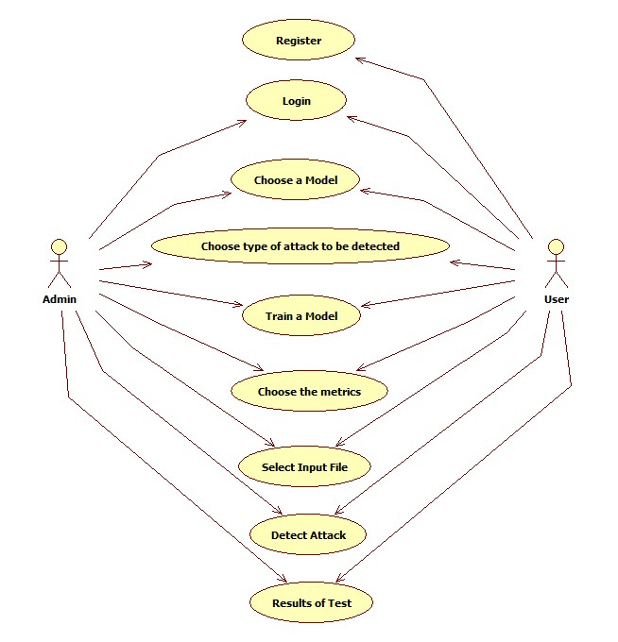

The refined use-case model is as follows,

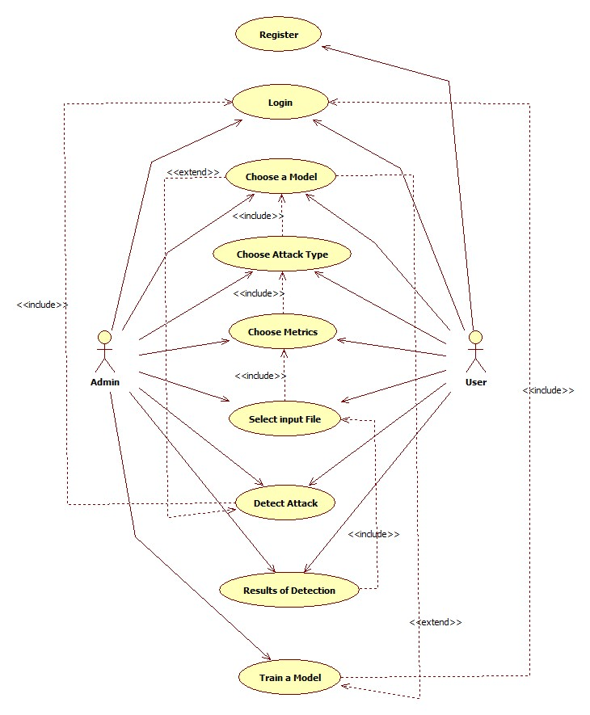

Use case specification:

**Name**: Register

**Actor**: Normal User

**Description**: User uses this use case to register inorder to use this application

**Pre-conditions:** User details such as username, email and password.

**Post-conditions:** Input of user details into the relevant database/storage media, resulting in creation of a user account.

**Normal Flow:**

1.1 Enter email address. (A-1)

1.2 Enter a unique username. (A-2)

1.3 Enter password as per specified requirements. Passwords must contain at least 8 characters, should contain at least one small-case, upper-case alphabet, a number, a special symbol. (A-3)

1.4 Submit

**Alternate Flow:**

A-1: If the entered email address is an existing one, prompt the user to enter another email address.

A-2: If the entered username is already taken, prompt the user to choose another username.

A-3: If the entered password is not meeting the requirements, prompt the user to choose another password.

**Priority :** Medium

**Frequency of Use :** Frequently used

**Scenario - 1**: An account is already created with the entered email address, so prompt the user to enter a different email address. Read username and password and acknowledge the user saying account is created.

**Scenario - 2:** Read the email address. The username entered is already taken by another user, so prompt the user to choose another username. Read password and acknowledge the user saying the account is created.

**Scenario - 3:** Read email address, username. The entered password does not meet the requirements of a password, so prompt the user to enter the correct password. Acknowledge the user saying the account is created.

**Activity Diagram:**

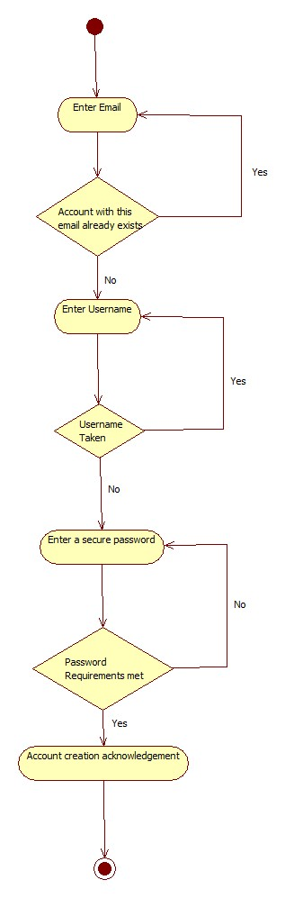

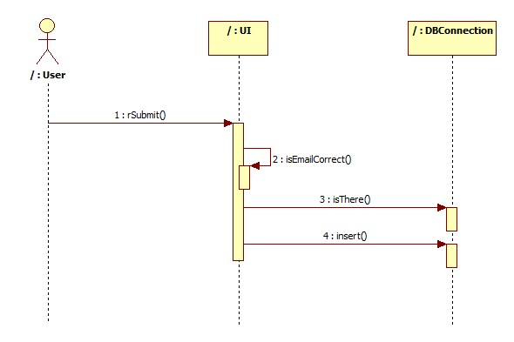

**Analysis Classes:**

1. User, Admin, System, Traffic, and Attack are the nouns in the user story.

Use case specification:

**Name**: Login

**Actor**: Normal User, Admin

**Description**: User uses this use case to login inorder to use this application

**Pre-conditions:** User details such as username and password.

**Post-conditions:** Input of username and password which are used to validate the user so that the user is let into the application to use it.

**Normal Flow:**

1.1 Enter Username (A -1)

1.2 Enter Password (A - 2)

1.3 Submit

**Alternate Flow:**

A - 1: If the entered username is not found, let the user know that the username is invalid.

A - 2: If the password entered is not matching with the username, let the user know that the password entered is invalid.

**Priority:** Medium

**Frequency of Use:** Frequently used

**Scenario - 1:** No account exists with the entered email address so prompt the user to enter to enter a valid username or ask the user to register if one hasn’t.

**Scenario - 2:** The entered password doesn’t match with the username entered so ask the user to re-enter a valid password.

